Multilevel selection on social network traits: resource and sex effects on levels of selection in experimental populations of forked fungus beetles

Abstract
Both individual and group social behaviors are expected to influence individual fitness. Multilevel selection, however, is rarely quantified on social behaviors. Social networks provide a unique opportunity to study multilevel selection on social behaviors, as they describe complex social traits at both the individual and group levels. In this study, we used contextual analysis to measure the effects of both individual social network position and group social network structure on individual fitness in experimental populations of forked fungus beetles (Bolitotherus cornutus). We further manipulated the distribution of fungus resources in these experimental populations to explore how habitat structure influences patterns of multilevel selection. We found that male beetles with high individual connectivity (strength) and centrality (betweenness) had higher mating success. However, group network structure did not influence male mating success. Conversely, we found that individual connectivity and centrality had no effect on female reproductive success but that females in populations with many social interactions and high network density experience lower reproductive success. The strength of individual-level selection in males and group-level selection in females intensified when fungus resources were clumped together rather than evenly distributed in space. Our results reveal that measuring multilevel selection on social behaviors across sexes and resource distributions uncovers otherwise overlooked fitness relationships. We discuss how our results inform our understanding of the evolution of sexual conflict and social networks.

Key Words: multilevel selection, contextual analysis, social behaviors, social networks, Bolitotherus cornutus

Main Text
Introduction
Populations are often subdivided into groups, and this subdivision alters how evolution proceeds (Wade and Goodnight 1998; Goodnight and Wade 2000). Instead of acting solely on differences among individuals, selection can act on differences among subpopulations (Heisler and Damuth 1987). When both individual and group phenotypes influence individual fitness, multilevel selection occurs (otherwise known as multilevel selection 1; Heisler and Damuth 1987; Goodnight et al. 1992). Most estimates of selection, however, ignore group-level effects (Kingsolver et al. 2001; Siepielski et al. 2009; Siepielski et al. 2013), limiting our understanding of selection and evolutionary responses.
Growing evidence demonstrates that individual and group traits concurrently influence individual fitness (Stevens et al. 1995; Tsuji 1995; Aspi et al. 2003; Donohue 2004; Weinig et al. 2007; Eldakar et al. 2010; Laiolo and Obeso 2012; Royle et al. 2012; Björklund and Gustafsson 2013; Bouwhuis et al. 2015; Fisher et al. 2017). These empirical studies provide important insights into how selection operates at multiple levels. We now know that patterns of multilevel selection vary across sexes and ecological contexts (Aspi et al. 2003; Bouwhuis et al. 2015; Fisher et al. 2017). For example, the strength of group selection often intensifies in high-density groups (Donohue 2004; Weinig et al. 2007). Past work also demonstrates that selection at the group level often opposes individual-level selection, likely maintaining constant yields in plants and sexual conflict in animals (Stevens et al. 1995; Tsuji 1995; Weinig et al. 2007; Eldakar et al. 2010; Laiolo and Obeso 2012).
Despite accumulating knowledge about patterns of multilevel selection, surprisingly little research investigates multilevel selection acting on social behaviors (but see Eldakar et al. 2010; Laiolo and Obseo 2012; Royle et al. 2012). Social behaviors, although often ascribed as individual phenotypes, inherently depend on interactions among individuals within groups. Selection at both these individual and group levels is expected to be a powerful force on social behaviors. Furthermore, environmental contexts that influence the frequency or type of social interactions that occur within groups likely modulate the strength of selection at both levels. Specifically, the distribution of critical resources is expected to alter the relative strength of individual and group selection by changing how individuals share space and interact (He et al. 2019). Further empirical work is required to understand how multilevel selection operates on social behaviors across ecological contexts.
Social networks provide a unique opportunity to quantify multilevel selection on social behaviors. Social networks comprehensively describe complex social behaviors that emerge from simple dyadic interactions at both the individual and group levels (Croft et al. 2008). For example, highly connected groups contain maximal interactions among individuals, whereas individuals that are highly connected in their social network interact often and with many conspecifics. Group and individual social networks differentially affect ecological and evolutionary processes (Croft et al. 2016). Group network traits influence how information and diseases spread within groups, where individual positions within networks affect how likely an individual is to contract diseases, receive information, and secure mates (Oh and Badyaev 2010; Allen et al. 2013; Webster et al. 2013; VanderWaal et al. 2014; Aplin et al. 2015). Both group and individual measures of social networks are expected to influence individual survival and reproductive success. Contextual analysis allows for selection to be partitioned into group and individual components to simultaneously detect selection on group and individual social network traits (Heisler and Damuth 1987; Goodnight et al. 1992).
Quantifying multilevel selection on social network traits additionally offers an opportunity to measure selection on emergent group traits. Emergent traits are group traits that are irreducible to the individual level, such as sex ratio or the connectivity of a social network. Most empirical estimates of multilevel selection measure selection on group averages of individual traits, not emergent group traits (Stevens et al. 1995; Tsuji 1995; Aspi et al. 2003; Donohue 2004; Weinig et al. 2007; Eldakar et al. 2010; Laiolo and Obseo 2012; Royle et al. 2012; Björklund and Gustafsson 2013; Bouwhuis et al. 2015; Fisher et al. 2017). The absence of emergent group traits in multilevel selection analyses has been viewed as a weakness of multilevel selection studies (reviewed in Okasha 2006). Social networks uniquely describe related individual and group traits without simply describing group phenotypes as averages of individual traits. As such, social networks are ideal for performing multilevel selection analyses on emergent group traits and their individual analogs, thereby filling a critical gap in the multilevel selection literature.
Understanding how social networks influence individual fitness is an important step towards revealing how fundamental social behaviors evolve (Fisher and McAdam 2017). A growing number of studies demonstrate that the position that an individual occupies within a social network influences individual fitness (Silk et al. 2003; McDonald 2007; Ryder et al. 2008; Silk et al. 2009; Oh and Badyaev 2010; Formica et al. 2012; Wey and Blumstein 2012; Brent et al. 2013; Gilby et al. 2013; Wey et al. 2013; Bar Ziv et al. 2016; Cheney et al. 2016; Lehmann et al. 2016; Formica et al. 2020). Similar to most estimates of selection, measures of selection acting on social networks focus on the individual level. Selection on group social network traits has rarely been quantified (but see Royle et al. 2012). As social networks are inherently properties of interacting individuals, understanding selection on network traits requires a multilevel framework (Fisher and McAdam 2017).
In this study, we quantified multilevel selection on individual and group social network traits in experimental populations of forked fungus beetles (Bolitotherus cornutus). Forked fungus beetles (Bolitotherus cornutus) are tenebrionid beetles that live on wood-rotting polypore shelf fungi in the forests of eastern North America (Ganoderma applanatum, Ganoderma tsugae, and Fomes fomentarius; Liles 1956). Beetles consume fungus tissue, females oviposit eggs singly on fungus surfaces, larvae develop inside fungus shelves, and social interactions take place on or near fungus shelves (Liles 1956; Pace 1967; Wood et al. 2018). The strong association with wood-rotting shelf fungi spatially subdivides wild populations of forked fungus beetles into subpopulations living on decaying logs. Within a breeding season, most adult beetles remain on a single log, although gene flow is sufficient to maintain genetic homogeneity among logs (Heatwole and Heatwole 1968; Ludwig 2008; Wood et al. 2013).
Beetles living on the same log repeatedly interact throughout a breeding season. Social interactions include mating interactions between males and females, agonistic interactions between males competing for access to mates, and proximity interactions among neighboring beetles (Pace 1967; Brown and Bartalon 1986; Conner 1988; Formica et al. 2012; Mitchem et al. 2019; Formica et al. 2020). Forked fungus beetles likely interact through chemical communication when in close proximity, as evidenced by beetles reorienting and waving their antennae when within a few body lengths and by females distinguishing among chemical cues of different males (Formica et al. 2017; Formica et al. 2020; Vilella-Pacheco et al. in press).
Social networks built from proximity interactions among beetles within a log form non-random structures, and the positions individuals hold within these networks influence male fitness in natural populations (Formica et al. 2012; Formica et al. 2020). Specifically, individual connectivity (strength) and individual centrality (betweenness) covary with male mating success, whereas individual cliquishness (local clustering coefficient) rarely influences male fitness (Formica et al. 2012; Formica et al. 2020). While we know that individual network position influences individual fitness, we are unable to partition selection into individual and group components of social networks in wild populations. This is because wild populations vary widely in size, and emergent social network structure closely covaries with population size (Formica et al. 2020).
Due to the limitations of field studies, we built experimental populations. These experimental populations allowed us to control many variables that naturally differ across wild populations, such as population size, and simultaneously manipulate a key difference across logs in the field, the distribution of fungus resources. Our previous analyses document that patterns of fungus distribution alter how beetles use space and interact socially (Costello 2020, Chapters 1 and 2). When fungus shelves are clumped together, beetles concentrate their activity around resource clumps, interact more often, and socialize in cliques (Costello 2020, Chapters 1 and 2). Fungus distribution, however, does not shape overall social network structure (Costello 2020, Chapter 2). As the distribution of fungus shelves affects different social network levels, we expect fungus distribution to likewise influence relative patterns of selection on individual and group social network traits.
In this study, we used experimental populations of forked fungus beetles to quantify multilevel selection on individual and group network characteristics in both sexes and in different resource distribution environments. We estimated multilevel selection on three different pairs of analogous individual and group social network metrics. We expected social network measures at both the individual and group levels to influence individual fitness in both sexes and to vary across different fungus distributions.

Methods
Experimental Populations
To quantify multilevel selection on individual and group social network characteristics, we established 12 experimental populations of forked fungus beetles. We built 8ft x 8ft x 4ft screen enclosures at Mountain Lake Biological Station (Giles County, Virginia) to house experimental populations (see also Costello 2020, Chapters 1 and 2). Each experimental population contained a 2.34m x 0.52m wooden shelving unit that acted as an artificial log, holding 54 polypropylene filter bags (SacO₂) filled with hardwood sawdust. Eighteen of these bags were inoculated with a cultivated strain of the host fungus, Ganoderma tsugae (Sharondale Mushroom Farm). Our strain of G. tsugae produced fungus shelves that did not differ in genotype, age, or volume.
To test whether resource distribution shapes patterns of multilevel selection on social network metrics, we manipulated the distribution of fungus shelves in the experimental populations. Eighteen bags with fungus shelves were aggregated into three discrete clumps in six of the experimental populations. In the other six populations, the fungus shelves were evenly dispersed across the artificial log. Thirty-six uninoculated bags spaced the inoculated bags apart. We swapped the resource distribution treatment between two observation periods. When switching the resource distribution treatment, we replaced the fungus shelves with newly inoculated bags, limiting fungus deterioration between observation periods. By exposing each experimental population to both resource distribution treatments, we performed a paired test and thereby controlled for fundamental differences among our populations.
We founded each experimental enclosure with 36 beetles. Beetles were collected from 126 different logs within a single metapopulation in Giles County, Virginia. To minimize previous social experience among beetles, we placed a maximum of three beetles collected from the same log in the same experimental population. We ensured that each population had the same sex ratio (18 males and 18 females) and similar body size distributions (linear model with elytra length as the dependent variable and population as the fixed effect: F_{11,420}=0.114, P=0.9998; average elytra length: 6.93mm). Five beetles died within the first three days of the experiment and were replaced with beetles of the same sex and size. Experimental population densities (one male per fungus shelf) fell within the range of densities observed in the field (Conner 1989; Formica et al. 2011).
We observed beetle interactions three times per day (0630, 1430, and 2130) for two three-week periods (June 27 – July 17, 2018 and July 27 – August 16, 2018). We acclimated beetles to their experimental enclosures for 36 hours before beginning observations. During observations, we systematically searched each population for beetles. Each beetle was labeled with a unique identification tag printed on florescent paper and affixed to its elytra with UV-cured acrylic (Tuffleye Wet-A-Hook Technologies). We used ultraviolet light to easily detect the fluorescent identification tags. We identified all social partners of observed beetles. We defined social partners as beetles within 5cm, several body lengths, of each other (as in Formica et al. 2020).

Social Networks
We used interactions between proximal social partners to construct social networks. Proximity interactions are often used to construct social networks in studies of animal behavior (Wey et al. 2013; Aplin et al. 2015; Leu et al. 2016; Snijders et al. 2017), and the positions individuals hold within proximity social networks have been shown to influence fitness in forked fungus beetles (Formica et al. 2012; Formica et al. 2020). We did not include courtship or mating interactions in our constructing our social networks to avoid non-independence between network variables and the fitness metrics in our multilevel selection analyses (see Multilevel Selection Analyses below; Formica et al. 2020). We used dyadic interactions, not group membership, to construct social networks, an important distinction when testing hypotheses in animal social networks (see Hypothesis Testing and Permutations below; Croft et al. 2011).
We converted dyadic proximity interactions into undirected, weighted social networks using the simple ratio index. The simple ratio index describes the association between social partners as weighted network edges, ranging from 0 for individuals never observed interacting together to 1 for individuals always observed interacting together (Ginsberg and Young 1992; Croft et al. 2008). We did not include interactions with unidentifiable beetles (2.96% of all interactions; occasionally labels were unreadable because of beetle position) in network construction. The 32 beetles that died during the observation periods were included in network construction but not in subsequent analyses. We built three types of social networks: both-sex networks describing interactions among all beetles, male-male networks describing interactions only among males, and female-female networks describing interactions only among females. We built separate networks for each experimental population during each observation period. To reset social networks between observation periods, we isolated individuals for four days before beginning the second observation period (Formica et al. 2017).
We calculated social network metrics that described the position of individuals within their network and the overall structure of the network. Individual strength describes how connected an individual is to the network by calculating how many different social partners an individual interacts with and how often. Individual strength is a weighted measure with repeated interactions between beetles only increasing individual strength by 0.5 (with an alpha weighting parameter of 0.5; Opsahl 2009). Individual betweenness provides a description of individual centrality and requires knowledge of the full social network. Individual betweenness is calculated as the number of shortest paths connecting two individuals that pass through the focal individual (Opsahl 2009). Local clustering coefficient describes individual cliquishness by measuring how often the social partners of an individual interact with each other (Croft et al. 2008). Beetles with one or no partners have undefined local clustering coefficients and were not included in models analyzing local clustering coefficient (see below in Multilevel Selection Analyses). Past work in wild populations of forked fungus beetles has detected selection on all three of these individual social network metrics in males (Formica et al. 2012; Formica et al. 2020).
We also calculated group-level network descriptors that are analogous to these three individual-level social network metrics. Network density measures how connected a network is by quantifying the number of network edges out of all possible edges in a network (Wasserman and Faust 1994). Average shortest path length likewise describes how connected a network is by calculating the average of the shortest path lengths that connect every pair of individuals (Opsahl 2009). Global clustering coefficient describes how modular a network is by calculating the proportion of all social partners that interact with each other (Opsahl 2009). Strength, betweenness, local clustering coefficient, average shortest path length, and global clustering coefficient were all calculated as weighted metrics in the tnet package in R (Opsahl 2009). Network density was calculated in the sna package in R (Butts 2016).

Multilevel Selection Analyses
We used contextual analysis to quantify multilevel selection on individual- and group-level social network metrics. Contextual analysis partitions selection into individual and group components using partial regression, an extension of the Lande-Arnold selection analysis (Lande and Arnold 1983; Heisler and Damuth 1987; Goodnight et al. 1992). Our contextual analyses separately examined three different combinations of individual and group traits: individual strength and network density; individual betweenness and average shortest path length; and local and global clustering coefficient. Each combination described analogous network properties but at different levels of organization. For example, individual strength quantifies how often an individual interacts whereas network density measures how interactive a network is. In each combination, the group social network metric was not simply a group average of the individual metric but instead described an emergent property of the social network.
In addition to the individual and group social network metrics, each contextual analysis included resource distribution treatment, trial period, individual elytra length, number of observations (a measure of individual activity), and the interactions between resource distribution treatment and social network metrics as fixed effects and beetle identification nested within experimental population as random effects. We ran separate models for males and females (N=200 males, N=200 females). For males, our dependent variable and fitness metric was the number of observed mate guarding events (Formica et al. 2012; Formica et al. 2020). Mate guarding reliably indicates spermatophore transfer and insemination success in male forked fungus beetles (Conner 1988; Conner 1989). For females, we used the number of observed egg laying events as a behavioral fitness metric indicating female reproductive success. In total, we ran six different contextual analyses using social network metrics calculated from both-sex networks. As post-hoc analyses, we ran two additional contextual models to explore multilevel selection on individual strength and network density in male-male only and female-female only social networks. In our analyses of selection on clustering, we removed individuals with undefined local clustering coefficients due to having no social partners (13 males and 4 females).
The scale of standardization in selection analyses requires explicit justification and should depend on the biological and ecological processes that generate selection (De Lisle and Svensson 2017). We mean-variance standardized individual social network metrics at the scale of each replicate experimental population, as selection on individual social network position in wild populations has been shown to operate within subpopulations (Formica et al. 2020). We likewise standardized the other individual phenotypes, elytra and number of observations, at the local population level. As group-level selection inherently operates across groups, we standardized group social network metrics at the global level across all experimental populations. Similarly, measuring multilevel selection necessitated relativizing fitness at the global scale. We performed all standardizations within observation period.
Models were built in the R package glmmTMB (Brooks et al. 2017). The R package emmeans was used to calculate marginal means (Lenth 2018). Figures were built in the R package ggeffect (Lüdecke 2018). All analyses were conducted in R version 3.6.2 (R Core Team 2019).

Hypothesis Testing and Permutations
The position an individual holds within its social network is the product of the behavior of both the individual and all its social partners. Individual social network metrics are thereby inherently non-independent and violate fundamental assumptions of parametric tests (Croft et al. 2011; Farine and Whitehead 2015; Farine 2017). We used node permutations to address this issue of non-independence. Node permutations shuffle characteristics of individuals, or nodes, across nodes within a social network (Croft et al. 2011). We chose to use node permutations instead of datastream permutations, as datastream permutations produce high false-positive error rates when testing null hypotheses in social networks (Puga-Gonzalez et al. 2020; Weiss et al. 2021). Although datastream permutation methods account for observation biases common to animal social networks, our direct observations of dyadic interactions in uniform experimental enclosures between easily identified individuals avoided common observation biases and made node permutations an appropriate choice for our analyses (Croft et al. 2011; Puga-Gonzalez et al. 2020).
Our node permutations randomly shuffled all variables used in the multilevel selection models without replacement among all individuals of the same sex to create 2000 permuted datasets. For each permuted dataset, we then ran the multilevel selection analyses described above (see Multilevel Selection Analyses) and extracted F-statistics for each fixed effect in each model, ultimately creating null distributions of 2000 F-statistics. We extracted F-statistics instead of model estimates because interactions between variables have multiple different model estimates. P-values were calculated as the proportion of permuted model F-statistics that were greater than the observed model F-statistic. Because our permutation method broke apart the covariance between individual and group social network metrics in the permuted datasets, we were able to test how often variance in fitness is partitioned between levels of social network organization by chance.

Results
In total, we observed 7865 social interactions. 852 interactions occurred between males, 2765 interactions occurred between females, and 4248 intersexual interactions occurred. We constructed twelve both-sex social networks from an average of 655.42 ± 99.61 social interactions per experimental population (mean ± standard deviation). For our post-hoc analyses, we constructed male-male social networks from 71.00 ± 22.67 social interactions and female-female social networks from 230.42 ± 44.28 social interactions (mean ± standard deviation).
We found selection acting on different levels of social network organization in males and females. In both-sex social networks, selection acted on individual strength and individual betweenness in males but on group network density in females (Table 1; Figures 1 and 2). Male beetles with higher individual strength and higher individual betweenness had higher mating success, but no measure of group network structure affected male mating success (Table 1; Figures 1 and 2). Conversely, female individual network position did not experience selection, but group network density covaried with female reproductive success (Table 1; Figures 1 and 2). Female beetles in networks with higher network density laid fewer eggs (Table 1; Figure 1). In the single-sex networks, although the same patterns of selection on individual strength held for males in male-male networks, network density of female-female networks was not under selection (Table 2; Figure 3). No selection on local or global clustering coefficient was detected for either males or females (Table 1; Figure 4).
Although resource distribution did not generate differences in fitness for either sex (Tables 1 and 2), resource distribution did impact the relationship between network traits and fitness. The strength of selection on network density for females varied between resource distribution treatments (Table 1; Figure 1). Females in both-sex networks with higher network density laid fewer eggs when fungus resources were clumped together but not when fungus shelves were evenly dispersed (Figure 1). Resource distribution similarly impacted the strength of selection on individual betweenness for males (Table 1; Figure 2). Males with high betweenness experienced higher male mating success when fungus resources were clumped together but not when fungus shelves were evenly dispersed (Figure 2). The distribution of fungus resources did not otherwise alter patterns of selection on individual and group social network characteristics (Tables 1 and 2; Figures 1 – 4).
Males with longer elytra, a measure of body size, had higher mating success, whereas female elytra length did not influence the number of eggs females laid (Tables 1 and 2). Observation period did not affect male mating success but accounted for variance in the number of eggs laid by females in the linear mixed model including individual strength and network density of both-sex networks (Tables 1 and 2). Beetles observed more often had higher mating and reproductive success (Tables 1 and 2), a typical result for selection analyses of this species (Formica et al. 2012; Formica et al. 2020).

Discussion
Both individual and group levels of social networks influenced individual fitness of forked fungus beetles (Bolitotherus cornutus). Males and females experienced fundamentally different levels of selection. Individual network position influenced male fitness, whereas overall network structure influenced female fitness. The distribution of fungus resources further amplified these patterns but did not change the level of selection experienced in each sex. Measuring multilevel selection across contexts uncovered fitness relationships otherwise ignored by traditional selection analyses on individual traits. Our results advocate for increased attention on the role of multilevel selection in evolutionary processes.

Individual-Level Selection
Selection on individual network position in experimental populations of forked fungus beetles generally recapitulated patterns of selection in wild populations (Formica et al. 2012; Formica et al. 2020). Congruent with recent analyses in wild populations, selection acted on male strength and betweenness but not local clustering coefficient in experimental populations (Formica et al. 2020; but see Formica et al. 2012). The direction of selection on male social network position varied across wild populations that likewise varied in demography and ecology (Formica et al. 2020). However, in our controlled experimental populations, male strength and betweenness consistently experienced positive selection. Individual strength of males in male-male networks likewise experienced positive selection in experimental populations. The fitness consequences of female individual social network position have not been explored in wild populations, and we found no relationship between female network position and female reproductive success.
Although individual-level selection on male social network position has been well documented in forked fungus beetles (Formica et al. 2012; Formica et al. 2020), the causal force generating the covariance between social network position and male mating success remains unknown. One potential factor is the availability of mates. Males that are more connected and more central in two-sex networks may interact more often with females and thereby experience more mating opportunities. This explanation, however, does not account for the positive selection we quantified acting on male strength in male-male networks, as male-male networks only include interactions among males. Alternatively, males who are highly connected and central within their network may increase their mating success by positioning themselves to receive more information about male competitors. The position an individual holds within a social network can impact their likelihood of receiving and transmitting information (Webster et al. 2013). Female forked fungus beetles use chemical cues to discriminate between winning and losing males (Vilella-Pacheco et al. 2021). Similar chemical cues may be more available to males holding central positions within their social network, providing connected males better evaluation of neighboring male competitors. Another possibility is that male social network position is correlated with a trait that is directly under selection. Successful males inherently hold highly connected social positions when competitors frequently challenge them. In this case, although social network position covaries with mating success, some other trait may drive male fitness.

Group-Level Selection
Group network structure also influenced variance in individual fitness but only among females. This difference between levels of selection experienced by males and females points to fundamental differences in how the social environment impacts male and female fitness. Furthermore, comparing female fitness relationships in two-sex networks to those in female-only networks suggests that interactions between males and females drive these selection gradients. Interlocus sexual conflict over mating interactions often reduces female fitness (Stutt and Siva-Jothy 2001; Arnqvist and Rowe 2005; Eldakar et al. 2010). In forked fungus beetles, males grapple with females before mating, a behavior characteristic to aggressive interactions between males (Mitchem et al. 2019). During courtship, males mount females for many hours, even as females lay eggs and traverse fungus shelves (Formica et al. 2016). These observations accumulate to suggest that interactions with males are costly to female forked fungus beetles and cause females to lay fewer eggs.
Although male interactions are likely costly to females, females with highly connected individual network positions did not experience fitness costs. Different potential explanations may account for this difference in the strength of group- and individual-level selection in females. One possibility is that more densely connected networks may promote more male aggression. Females in populations with more aggressive males may experience more grappling either directly or indirectly from fights between males mounted on top of females. Alternatively, females in populations with more aggressive males may be sperm limited if competition among males distracts from mate acquisition. A similar behavioral mechanism has been provided as an explanation for variation in sexual selection on male size in natural populations of forked fungus beetles (Conner 1989; Formica et al. 2011). Whatever the mechanism, females in densely connected networks experienced reduced reproductive output, irrespective of their own individual connectedness within the network. This result showcases that group-level selection on emergent network properties can act independently of selection on individual-level network analogs and underscores the importance of selection on emergent group traits.

Sex-Specific Patterns of Multilevel Selection
Considering sex-specific selection at multiple levels of social network organization in forked fungus beetles revealed sexually antagonistic selection across levels. More connected and central males secured more mates, whereas females in more connected groups produced fewer eggs. Males and females often experience selection acting in opposite directions on shared traits, and these conflicting selection pressures frequently result in sexually dimorphic traits that maintain sexually antagonistic alleles within populations (Cox and Calsbeek 2009). Although a powerful force for maintaining genetic variation, sexually antagonistic selection has not previously been found to act across levels of organization. Indeed, this is only the second study to investigate how multilevel selection varies across the sexes. Fisher et al. (2017) found that female red squirrels (Tamiasciurus hudsonicus) experienced strong selection on growth rate within-litters while males experienced no within-litter selection. Analyses within one sex found conflicting multilevel selection in water striders (Aquarius remigis), where more aggressive individual males but groups of less aggressive males experienced higher mating success (Eldakar et al. 2010). In water striders, female dispersal away from groups of aggressive males mediated these opposing selective forces on male aggression. In forked fungus beetles, however, group-level selection in females opposed individual-level selection in males. If sexually antagonistic selection commonly operates across levels, the phenotypic composition of groups may play a previously underappreciated role in intralocus sexual conflict and the maintenance of genetic variation. Our results add support to the call to analyze selection across sexes and at multiple levels (Cox and Calsbeek 2009; Eldakar et al. 2010; Fisher et al. 2017).

Effect of Resource Distribution on Patterns of Multilevel Selection
Patterns of multilevel selection also differed between patterns of resource distribution, with stronger individual- (males) and network- level (females) selection experienced when fungus resources were distributed in discrete clumps. Our previous analyses established that beetles concentrated their space use around resource patches and interacted more often and in cliques when fungus shelves were clumped (Costello 2020, Chapters 1 and 2). This change in social behavior likely accounted for the increased selection in environments with clumped resources, as conspecific interactions likely mediated selection on both betweenness in males and network density in females. The observed difference in selection across experimentally manipulated distributions of fungus resources may provide insight into patterns of selection in wild populations. Variable selection on male social network position observed in wild populations (Formica et al. 2020) may correspond to variable distributions of fungus shelves along logs.
Variation in the strength of multilevel selection across environments aligns with patterns observed in multilevel selection analyses across a wide range of taxa (Aspi et al. 2003; Donohue 2004; Weinig et al. 2007; Bouwhuis et al. 2015; Fisher et al. 2017). The strength of group-level selection typically increases in more dense populations in both plants and animals (Aspi et al. 2003; Donohue 2004; Weinig et al. 2007; Fisher et al. 2017; but see Bouwhuis et al. 2015). Multilevel selection across contexts other than conspecific density, however, has rarely been investigated (but see Aspi et al. 2003; Bouwhuis et al. 2015). Bouwhuis et al. (2015) creatively used multilevel selection to identify ecological agents of selection in great tits (Parus major). Food availability modulated higher-level selection, whereas predation and conspecific density affected individual-level selection. Adding to Bouwhuis et al. (2015), we employed an experimental manipulation and found that an environmental axis other than conspecific density modulated multilevel selection.

Multilevel Selection on Emergent Group Traits
Our results fill a critical gap in the ongoing debate over the evolutionary importance of multilevel selection. This debate, in part, centers on the type of group trait experiencing selection, group averages of individual traits versus emergent group traits (Gardner 2015; Goodnight 2015). When group-level selection acts on group averages of individual traits, some researchers expect an inconsequential evolutionary response to group-level selection compared to individual-level selection, while others assert that the distinction between types of group traits is irrelevant (reviewed in Okasha 2006; Eldakar and Wilson 2011). We provide empirical evidence of group-level selection acting on an emergent group trait, adding to literature dominated by group averages of individual traits. Furthermore, we demonstrate that selection can operate on emergent group-level properties without acting on analogous individual-level traits, lending credence to the relative importance of group-level selection.

Evolution of Social Networks
Social networks describe properties of interacting individuals, and understanding how social networks evolve thereby requires a multilevel selection framework (Fisher and McAdam 2017). Although individual-level selection on network position has been well documented in a wide range of organisms (Silk et al. 2003; McDonald 2007; Ryder et al. 2008; Silk et al. 2009; Oh and Badyaev 2010; Formica et al. 2012; Wey and Blumstein 2012; Brent et al. 2013; Gilby et al. 2013; Wey et al. 2013; Bar Ziv et al. 2016; Cheney et al. 2016; Lehmann et al. 2016; Formica et al. 2020), the effect of overall network structure on individual fitness has been rarely quantified. In a rare look at selection on group social network traits, Royle et al. (2012) found that nestling great tits in families with higher mean strength better resolved conflicts over parental investment and were more likely to survive. This study considered selection on average strength and then dropped individual strength from the selection analysis. We add to Royle et al. (2012) by using contextual analyses to quantify how selection simultaneously operates on individual and group social network traits. Without applying a multilevel selection framework across sexes and resource distributions, we would fail to fully understand the social and ecological variables shaping the evolution of social networks.
Predicting how social networks evolve in response to multilevel selection is an ongoing challenge (Fisher and McAdam 2017). First, for social networks to respond to multilevel selection, there must be some transmissible component of network structure across generations. Although additive genetic variance has been found for some aspects of individual social network position (Fowler et al. 2009; Lea et al. 2010; Brent et al. 2013), the potential for heritability of emergent social network traits is currently unknown. Furthermore, we know very little about the relationship between individual and group social network traits (Cantor et al. 2020). If individual and group network traits are correlated, selection at one level may either accelerate or constrain evolution at another level (Bijma and Wade 2008). In this study, males with higher individual connectedness (strength) and individual centrality (betweenness) secured more mates, but females produced more eggs when in less connected (dense) networks. Depending on the relationship between individual and group connectedness, the evolution of more connected males may be constrained by reduced reproductive output of females in more connected networks (Goodnight et al. 1992). Future research on the genetic underpinnings and interrelatedness of individual and group network traits is required for understanding the evolutionary implications of sex- and context- dependent multilevel selection on social networks.
References
Allen, J., M. Weinrich, W. Hoppitt, and L. Rendell. 2013. Network-based diffusion analysis
reveals cultural transmission of lobtail feeding in humpback whales. Science 340:485–488.
Aplin, L. M., D. R. Farine, J. Morand-Ferron, A. Cockburn, A. Thorton, and B. C. Sheldon.
2015. Experimentally induced innovations lead to persistent culture via conformity in wild birds. Nature 518:538–541.
Arnqvist, G., and L. Rowe. 2005. Sexual Conflict. Princeton University Press, Princeton, NJ.
Aspi, J., A. Jäkäläniemi, J. Tuomi, and P. Siikamäki. 2003. Multilevel phenotypic selection on
morphological characters in a metapopulation of Silene tatarica. Evolution 57:509–517.
Bar Ziv, E., A. Ilany, V. Demartsev, A. Barocas, E. Geffen, and L. Koren. 2016. Individual,
social, and sexual niche traits affect copulation success in a polygynadrous mating system. Behav. Ecol. and Sociobiol. 70:901–912.
Bijma, P., and M. J. Wade. 2008. The joint effects of kin, multilevel selection and indirect
genetic effects on response to genetic selection. J. Evol. Biol. 21:1175–1188.
Björklund, M., and L. Gustafsson. 2013. The importance of selection at the level of the pair over
25 years in a natural population of birds. Ecol. Evol. 3:4610–4619.
Bouwhuis, S., O. Vedder, C. J. Garroway, and B. C. Sheldon. 2015. Ecological causes of
multilevel covariance between size and first-year survival in a wild bird population. J. Anim. Ecol. 84:208–218.
Brent, L. J. N., S. R. Heilbronner, J. E. Horvath, J. Gonzalez-Martinez, A. Ruiz-Lambides, A. G.
Robinson, J. H. P. Skene, and M. L. Platt. 2013. Genetic origins of social networks in rhesus macaques. Sci. Rep. 3:1042.
Brooks, M. E., K. Kristensen, K. J. van Benthem, A. Magnusson, C. W. Berg, A. Nielsen, H. J.
Skaug, M. Maechler, and B. M. Bolker. 2017. glmmTMB balances speed and flexibility among packages for zero-inflated generalized linear mixed modeling. R J. 9:378–400.
Brown, L., and J. Bartalon. 1986. Behavioral correlates of male morphology in a horned beetle.
Am. Nat. 127:565–570.
Butts, C. T. 2016. sna: tools for social network analysis. R package version 2.4.
Cantor, M., A. A. Maldonado-Chaparro, K. B. Beck, H. B. Brandl, G. G. Carter, P. He, F.
Hillemann, J. A. Klarevas-Irby, M. Ogino, D. Papegeorgiou, L. Prox, and D. R. Farine. 2020. The importance of individual-to-society feedback in animal ecology and evolution. J. Anim. Ecol. 90:27-44.
Cheney, D. L., J. B. Silk, and R. M. Seyfarth. 2016. Network connections, dyadic bonds and
fitness in wild female baboons. R. Soc. Open Sci. 3:160255.
Conner, J. K. 1988. Field measurements of natural and sexual selection in the fungus beetle,
Bolitotherus cornutus. Evolution 42:736–749.
Conner, J. K. 1989. Density-dependent sexual selection in the fungus beetle, Bolitotherus
cornutus. Evolution 43:1378–1386.
Cook, P. A., O. M. Baker, R. A. Costello, V. A. Formica, and E. D. Brodie III. in prep. Social
network structure is shaped by social phenotypes of group members.
Costello, R. A. 2020. The ecological causes and adaptive consequences of social behaviors in
forked fungus beetles (Bolitotherus cornutus). PhD thesis, University of Virginia.
Cox, R. M., and R. Calsbeek. 2009. Sexually antagonistic selection, sexual dimorphism, and the
resolution of intralocus sexual conflict. Am. Nat. 173:176–187.
Croft, D. P., R. James, and J. Krause. 2008. Exploring animal social networks. Princeton
University Press, Princeton, NJ.
Croft, D. P., J. R. Madden, D. W. Franks, and R. James. 2011. Hypothesis testing in animal
social networks. Trends Ecol. and Evol. 26:502–507.
Croft, D. P., S. K. Darden, and T. W. Wey. 2016. Current directions in animal social networks.
Curr. Opin. Behav. Sci. 12:52–58.
De Lisle, S. P., and E. I. Svensson. 2017. On the standardization of fitness and traits in
comparative studies of phenotypic selection. Evolution 71:2313–2326.
Donohue, K. 2004. Density-dependent multilevel selection in the Great Lakes sea rocket.
Ecology 85:180–191.
Eldakar, O. T., D. S. Wilson, M. J. Dlugos, and J. W. Pepper. 2010. The role of multilevel
selection in the evolution of sexual conflict in the water strider Aquarius remigis. Evolution 64:3183–3189.
Eldkar, O. T., and D. S. Wilson. 2011. Eight criticism not to make about group selection.
Evolution 65:1523-1526.
Farine, D. R., and H. Whitehead. 2015. Constructing, conducting and interpreting animal social
network analysis. J. Anim. Ecol. 84:1144–1163.
Farine, D. R. 2017. A guide to null models for animal social network analysis. Methods Ecol.
Evol. 8:1309–1320.
Fisher, D. N., S. Boutin, B. Dantzer, M. M. Humphries, J. E. Lane, and A. G. McAdam. 2017.
Multilevel and sex-specific selection on competitive traits in North American red squirrels. Evolution 71:1841–1854.
Fisher, D. N., and A. G. McAdam. 2017. Social traits, social networks and evolutionary biology.
J. Evol. Biol. 30:2088–2103.
Formica, V. A., J. W. McGlothlin, C. W. Wood, M. E. Augat, R. E. Butterfield, M. E. Barnard,
and E. D. Brodie III. 2011. Phenotypic assortment mediates the effect of social selection in a wild beetle population. Evolution 65:2771–2781.
Formica, V. A., C. W. Wood, W. B. Larsen, R. E. Butterfield, M. E. Augat, H. Y. Hougen, and
E. D. Brodie III. 2012. Fitness consequences of social network position in a wild population of forked fungus beetles (Bolitotherus cornutus). J. Evol. Biol. 25:130–137.
Formica, V. A., H. Donald-Cannon, and I. E. Perkins-Taylor. 2016. Consistent patterns of male
mate preference in the laboratory and field. Behav. Ecol. Sociobiol. 70:1805–1812.
Formica, V., C. Wood, P. Cook, and E. Brodie III. 2017. Consistency of animal social networks
after disturbance. Behav. Ecol. Sociobiol. 28:85–93.
Formica, V. A., H. M. Donald, H. E. Marti, Z. Irgebay, and E. D. Brodie III. 2020. Social
network position experiences more variable selection than weaponry in wild subpopulations of forked fungus beetles. J. Anim. Ecol. doi: 10.1111/1365-2656.13322
Fowler, J. H., C. T. Dawes, and N. A. Christakis. 2009. Model of genetic variation in human
social networks. PNAS 106:1720–1724.
Gardner, A. 2015. The genetical theory of multilevel selection. J. Evol. Biol. 28:305–319.
Gilby, I. C., L. J. N. Brent, E. E. Wroblewski, R. S. Rudicell, B. H. Hahn, J. Goodall, and A. E.
Pusey. 2013. Fitness benefits of coalitionary aggression in male chimpanzees. Behav. Ecol. Sociobiol. 67:373–381.
Ginsberg, J. R., and T. P. Young. 1992. Measuring association between individuals or groups in
behavioral studies. Anim. Behav. 44:377–379.
Goodnight, C. J., J. M. Schwartz, and L. Stevens. 1992. Contextual analysis of models of group
selection, soft selection, hard selection, and the evolution of altruism. Am. Nat. 140:743–761.
Goodnight, C. J., and M. J. Wade. 2000. The ongoing synthesis: a reply to Coyne, Barton, and
Turelli. Evolution 54:317–324.
Goodnight, C. J. 2015. Multilevel selection theory and evidence: a critique of Gardner, 2015.
J. Evol. Biol. 28:1734–1746.
He, P., A. A. Maldonado-Chaparro, and D. R. Farine. 2019. The role of habitat configuration in
shaping social structure: a gap in studies of animal social complexity. Behav. Ecol.
Sociobiol. 73:9.
Heatwole, H., and A. Heatwole. 1968. Movements, host-fungus preferences, and longevity of
Bolitotherus cornutus (Coleoptera: Tenebrionidae). Ann. Entomol. Soc. Am. 61:18–23.
Heisler, I. L., and J. Damuth. 1987. A method for analyzing selection in hierarchically structured
populations. Am. Nat. 130:582–602.
Kingsolver, J. G., H. E. Hoekstra, J. M. Hoekstra, D. Berrigan, S. N. Vignieri, C. E. Hill, A.
Hoang, P. Gibert, and P. Beerli. 2001. The strength of phenotypic selection in natural populations. Am. Nat. 157:245–261.
Laiolo, P., and J. R. Obeso. 2012. Multilevel selection and neighbourhood effects from
individual to metapopulation in a wild passerine. PLoS One 7:e38526.
Lande, R., and S. J. Arnold. 1983. The measurement of selection on correlated characters.
Evolution 37:1210–1226.
Lea, A. J., D. T. Blumstein, T. W. Wey, and J. G. A. Martin. 2010. Heritable victimization and
the benefits of agonistic relationships. PNAS 107:21587–21592.
Lehmann, J., B. Majolo, and R. McFarland. 2016. The effects of social network position on the
survival of wild Barbary macaques, Macaca sylvanus. Behav. Ecol. 27:20–28.
Lenth, R. 2018. emmeans: Estimated marginal means, aka least-squares means. R package.
Leu, S. T., D. R. Farine, T. W. Wey, A. Sih, and C. M. Bull. 2016. Environment modulates
population social structure: experimental evidence from replicated social networks of wild lizards. Anim. Behav. 111:23–31.
Liles, M. P. 1956. A study of the life history of the forked fungus beetle, Bolitotherus cornutus
(Panzer) (Coleoptera: Tenebrionidae). Ohio J. Sci. 56:329–337.
Lüdecke, D. 2018. ggeffects: Tidy data frames of marginal effects from regression models.
J. Open Source Softw. 3:772.
Ludwig, P. 2008. Causes and consequences of dispersal in the forked fungus beetle. PhD thesis,
University of Virginia.
McDonald, D. B. 2007. Predicting fate from early connectivity in a social network. PNAS
104:10910–10914.
Mitchem, L. D., R. Debray, V. A. Formica, and E. D. Brodie III. 2019. Contest interactions and
outcomes: relative body size and aggression independently predict contest status. Animal Behaviour 157:43–49.
Oh, K. P., and A. V. Badyaev. 2010. Structure of social networks in a passerine bird:
consequences for sexual selection and the evolution of mating strategies. Am. Nat. 176:E80–E89.
Okasha, S. 2006. Evolution and the Levels of Selection. Oxford University Press, Oxford.
Opsahl, T. 2009. Structure and evolution of weighted networks. University of London, London.
Pace, A. E. 1967. Life history and behavior of a fungus beetle, Bolitotherus cornutus
(Tenebrionidae). Occas. Pap. Mus. Zool. Univ. Mich. 653:1114–1128.
Puga-Gonzalez, I., C. Sueur, and S. Sosa. 2020. Null models for animal social network analysis
and data collected via focal sampling: pre-network or node network permutation? Methods Ecol. Evol. 12:22–32.
R Core Team. 2019. R: a language and environment for statistical computing. R Foundation for
Statistical Computing, Vienna.
Royle, N. J., T. W. Pike, P. Heeb, H. Richner, and M. Kölliker. 2012. Offspring social network
structure predicts fitness in families. Proc. Royal Soc. B 279:4914–4922.
Ryder, T. B., D. B. McDonald, J. G. Blake, P. G. Parker, and B. A. Loiselle. 2008. Social
networks in lek-mating wire-tailed manakin (Pipra filicauda). Proc. Royal Soc. B 275:1367–1374.
Siepielski, A. M., J. D. DiBattista, and S. M. Carlson. 2009. It’s about time: the temporal
dynamics of phenotypic selection in the wild. Ecol. Lett. 12:1261–1276.
Siepielski, A. M., K. M. Gotanda, M. B. Morrissey, S. E. Diamond, J. D. DiBattista, and S. M.
Carlson. 2013. The spatial patterns of directional phenotypic selection. Ecol. Lett. 16:1382–1392.
Silk, J. B., S. C. Alberts, and J. Altmann. 2003. Social bonds of female baboons enhance infant
survival. Science 302:1231–1234.
Silk, J. B., J. C. Beehner, T. J. Bergman, C. Crockford, A. L. Engh, L. R. Moscovice, R. M.
Wittig, R. M. Seyfarth, and D. L. Cheney. 2009. The benefits of social capital: close social bonds among female baboons enhance offspring survival. Proc. Royal Soc. B 276:3099–3104.
Snijders, L., D. T. Blumstein, C. R. Stanley, and D. W. Franks. 2017. Animal social network
theory can help wildlife conservation. Trends Ecol. Evol. 31:567–577.
Stevens, L., C. J. Goodnight, and S. Kalisz. 1995. Multilevel selection in natural populations of
Impatiens capensis. Am. Nat. 145:513–526.
Stutt, A. D., and M. T. Siva-Jothy. 2001. Traumatic insemination and sexual conflict in the bed
bug Cimex lectularius. PNAS 98:5683–5687.
Tsuji, K. 1995. Reproductive conflicts and levels of selection in the ant Pristomyrmex pungens:
contextual analysis and partitioning of covariance. Am. Nat. 146:586–607.
VanderWaal, K. L., E. R. Atwill, L. A. Isbell, and B. McCowan. 2014. Linking social and
pathogen transmission networks using microbial genetics in giraffe (Giraffa camelopardalis). J. Anim. Ecol. 83:406–414.
Vilella-Pacheco, Z., L. D. Mitchem, V. A. Formica, and E. D. Brodie III. 2021. Male
competition reverses female preference for male chemical cues. Ecology and Evolution. doi:10.1022/ece3.7348.
Wade, M. J., and C. J. Goodnight. 1998. Perspective: the theories of Fisher and Wright in the
context of metapopulations: when nature does many small experiments. Evolution 52:1537–1553.
Wasserman, S., and K. Faust. 1994. Social network analysis: methods and applications.
Cambridge University Press, Cambridge.
Webster, M. M., N. Atton, W. J. E. Hoppitt, and K. N. Laland. 2013. Environmental complexity
influences association network structure and network-based diffusion of foraging information in fish shoals. Am. Nat. 181:235–244.
Weinig, C., J. A. Johnston, C. G. Willis, and J. N. Maloof. 2007. Antagonistic multilevel
selection on size and architecture in variable density settings. Evolution 61:58–67.
Weiss, M. N., D. W. Franks, L. J. N. Brent, S. Ellis, M. J. Silk, and D. P. Croft. 2021. Common
datastream permutations of animal social network data are not appropriate for hypothesis
testing using regression models. Methods Ecol. Evol. 12:255-265.
Wey, T. W., and D. T. Blumstein. 2012. Social attributes and associated performance measures
in marmots: bigger male bullies and weakly affiliating females have higher annual reproductive success. Behav. Ecol. Sociobiol. 66:1075–1085.
Wey, T. W., J. R. Burger, L. A. Ebensperger, and L. D. Hayes. 2013. Reproductive correlates of
social network variation in plurally breeding degus (Octodon degus). Anim. Behav.
85:1407–1414.
Wood, C. W., H. M. Donald, V. A. Formica, and E. D. Brodie III. 2013. Surprisingly little
population genetic structure in a fungus-associated beetle despite its exploitation of multiple hosts. Ecol. Evol. 3:1484–1494.
Wood, C. W., E. W. Wice, J. del Sol, S. Paul, B. J. Sanderson, and E. D. Brodie III. 2018.
Constraints imposed by a natural landscape override offspring fitness effects to shape oviposition decisions in wild forked fungus beetles. Am. Nat. 191:524–538.
Tables and Figures
Table 1. Multilevel selection on individual network positions and group network traits in both-sex networks. Linear mixed model estimates are reported for continuous variables and marginal means are reported for categorical variables. P-values are calculated as the proportion of permuted model F-statistics that were greater than the observed model F-statistic. Significant P-values at the α=0.05 level are bolded.
Males | Individual Strength,  Network Density |  | Individual Betweenness,  Average Shortest Path |  | Local Clustering,  Global Clustering
Fixed Effect | Estimate | P-value | Estimate | P-value | Estimate | P-value
Individual Network Position | 0.351 | <0.001 | 0.142 | <0.001 | 0.031 | 0.42
Group Network Trait | 0.001 | 0.97 | -0.002 | 0.97 | -0.021 | 0.60
Treatment | Clumped: 0.974  Dispersed: 1.028 | 0.38 | Clumped: 0.977  Dispersed: 1.031 | 0.42 | Clumped: 0.977  Dispersed: 1.023 | 0.49
Elytra Length | 0.113 | 0.002 | 0.147 | 0.001 | 0.175 | <0.001
Number of Observations | 0.162 | <0.001 | 0.247 | <0.001 | 0.260 | <0.001
Observation Period | Period 1: 0.995  Period 2: 1.006 | 0.67 | Period 1: 1.000  Period 2: 1.010 | 0.86 | Period 1: 1.004  Period 2: 0.996 | 0.75
Individual Network Position*Treatment | Clumped: 0.398  Dispersed: 0.304 | 0.16 | Clumped: 0.213  Dispersed: 0.071 | 0.05 | Clumped: -0.016  Dispersed: 0.077 | 0.22
Group Network Trait*Treatment | Clumped: 0.023  Dispersed: -0.021 | 0.57 | Clumped: -0.026  Dispersed: 0.023 | 0.56 | Clumped: -0.032  Dispersed: -0.009 | 0.77
Females | Individual Strength,  Network Density |  | Individual Betweenness,  Average Shortest Path |  | Local Clustering,  Global Clustering
Fixed Effect | Estimate | P-value | Estimate | P-value | Estimate | P-value
Individual Network Position | 0.011 | 0.81 | -0.007 | 0.88 | -0.050 | 0.22
Group Network Trait | -0.087 | 0.031 | 0.054 | 0.25 | -0.039 | 0.38
Treatment | Clumped: 1.008  Dispersed: 0.979 | 0.69 | Clumped: 0.999  Dispersed: 0.979 | 0.82 | Clumped: 1.027  Dispersed: 0.965 | 0.42
Elytra Length | -0.033 | 0.47 | -0.036 | 0.42 | -0.024 | 0.57
Number of Observations | 0.225 | <0.001 | 0.233 | <0.001 | 0.202 | <0.001
Observation Period | Period 1: 1.023  Period 2: 0.964 | <0.001 | Period 1: 0.996  Period 2: 0.981 | 0.29 | Period 1: 0.990  Period 2: 1.000 | 0.39
Individual Network Position*Treatment | Clumped: 0.000  Dispersed: 0.021 | 0.80 | Clumped: -0.017  Dispersed: 0.003 | 0.80 | Clumped: -0.053  Dispersed: -0.047 | 0.94
Group Network Trait*Treatment | Clumped: -0.192  Dispersed: 0.018 | 0.019 | Clumped: 0.116  Dispersed: -0.007 | 0.23 | Clumped: -0.020  Dispersed: -0.058 | 0.74

Table 2. Multilevel selection on individual strength and network density in males in male-male networks and females in female-female networks. Model estimates are reported for continuous variables and marginal means are reported for categorical variables. P-values are calculated as the proportion of permuted model F-statistics that were greater than the observed model F-statistic. Significant P-values at the α=0.05 level are bolded.
Males |  |  |  | Females
Fixed Effect | Estimate | P-value |  | Fixed Effect | Estimate | P-value
Individual Strength | 0.207 | <0.001 |  | Individual Strength | -0.013 | 0.78
Network Density | -0.016 | 0.67 |  | Network Density | -0.001 | 0.97
Treatment | Clumped: 0.097  Dispersed: 1.027 | 0.37 |  | Treatment | Clumped: 1.017  Dispersed: 0.976 | 0.60
Elytra Length | 0.172 | <0.001 |  | Elytra Length | -0.035 | 0.42
Number of Observations | 0.226 | <0.001 |  | Number of Observations | 0.236 | <0.001
Observation Period | Period 1: 1.002  Period 2: 0.997 | 0.88 |  | Observation Period | Period 1: 0.996  Period 2: 0.997 | 0.99
Individual Strength*Treatment | Clumped: 0.204  Dispersed: 0.210 | 0.93 |  | Individual Strength*Treatment | Clumped: -0.012  Dispersed: -0.013 | 0.98
Network Density*Treatment | Clumped: -0.027  Dispersed: -0.005 | 0.79 |  | Network Density*Treatment | Clumped: 0.013  Dispersed: -0.016 | 0.78

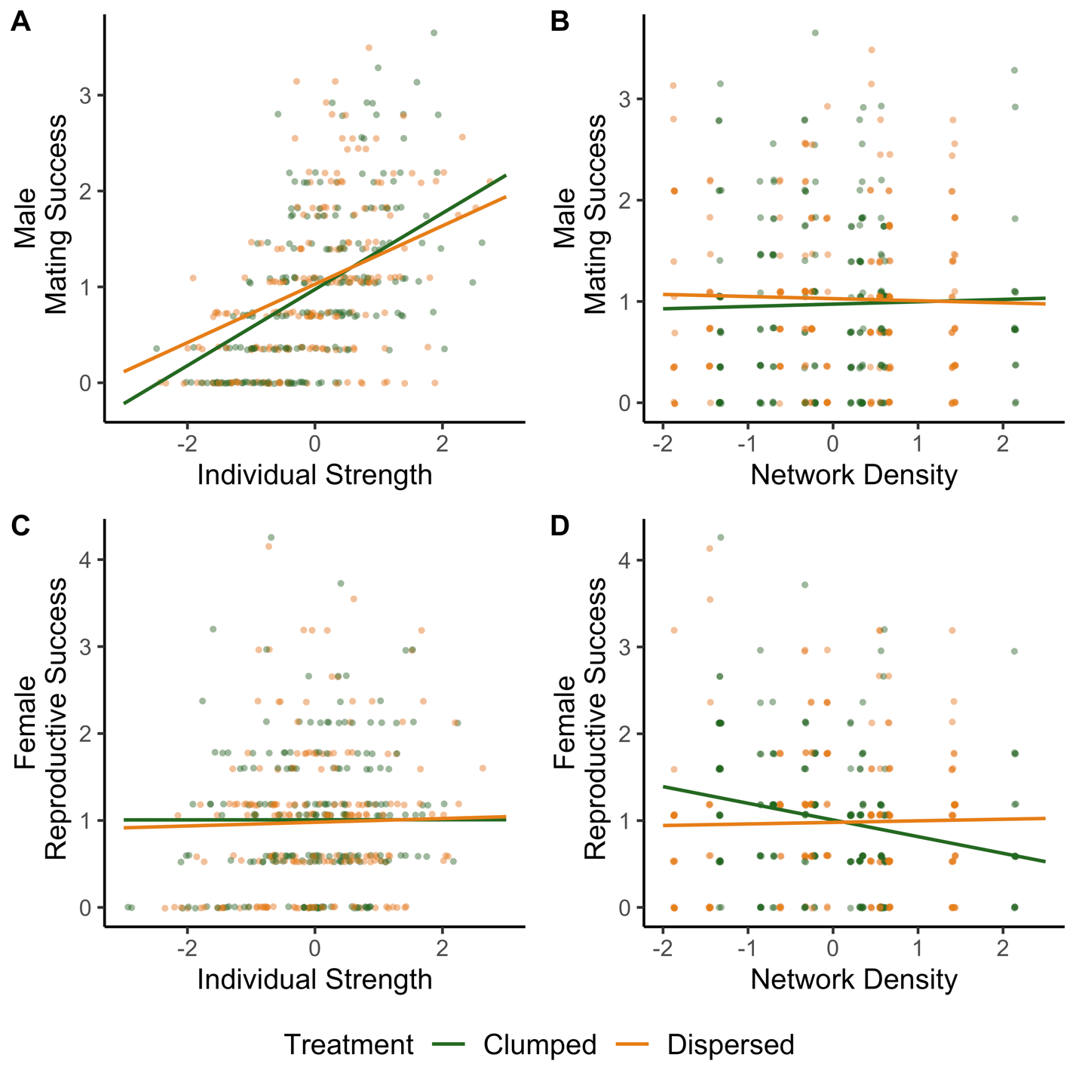
Figure 1. Marginal effects of individual strength and both-sex network density on male mating success and female reproductive success. (A) Male individual strength positively predicts male mating success. (B) Both-sex network density does not affect male mating success. (C) Female individual strength does not affect the number of eggs laid. (D) Both-sex network density negatively predicts the number of eggs laid. The color of the points and gradients represent fungus resource distribution in the experimental populations. Green denotes clumped fungus resources, and orange denotes dispersed fungus resources. Confidence intervals are not included as permutation testing was used to assess significance.

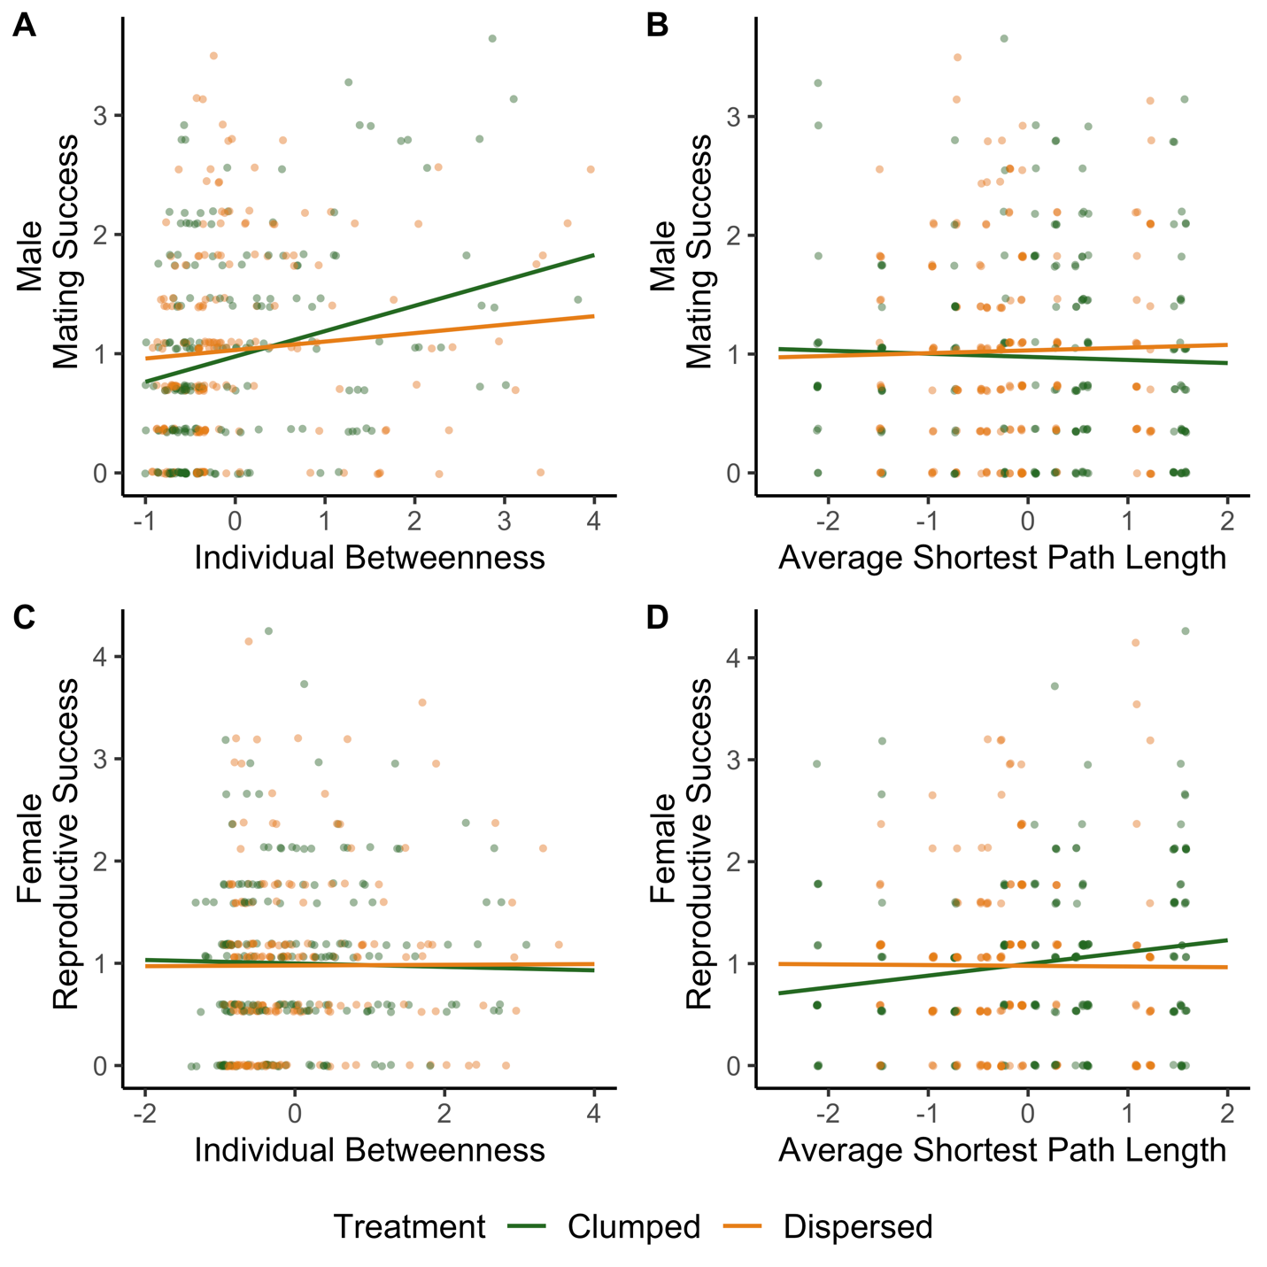
Figure 2. Marginal effects of individual betweenness and both-sex average shortest path length on male mating success and female reproductive success. (A) Male individual betweenness positively predicts male mating success. (B) Both-sex average shortest path length does not affect male mating success. (C) Female individual betweenness does not affect the number of eggs laid. (D) Both-sex average shortest path length does not influence the number of eggs laid. The color of the points and gradients represent fungus resource distribution in the experimental populations. Green denotes clumped fungus resources, and orange denotes dispersed fungus resources. Confidence intervals are not included as permutation testing was used to assess significance.
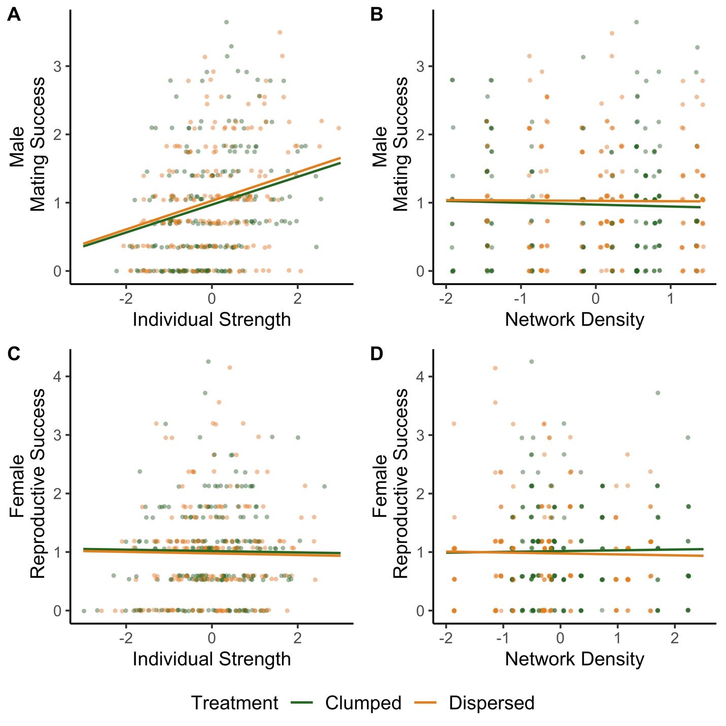
Figure 3. Marginal effects of individual strength and male-male network density on male mating success and of individual strength and female-female network density on female reproductive success. (A) Male individual strength positively predicts male mating success. (B) Male-male network density does not affect male mating success. (C) Female individual strength does not affect the number of eggs laid. (D) Female-female network density does not affect the number of eggs laid. The color of the points and gradients represent fungus resource distribution in the experimental populations. Green denotes clumped fungus resources, and orange denotes dispersed fungus resources. Confidence intervals are not included as permutation testing was used to assess significance.

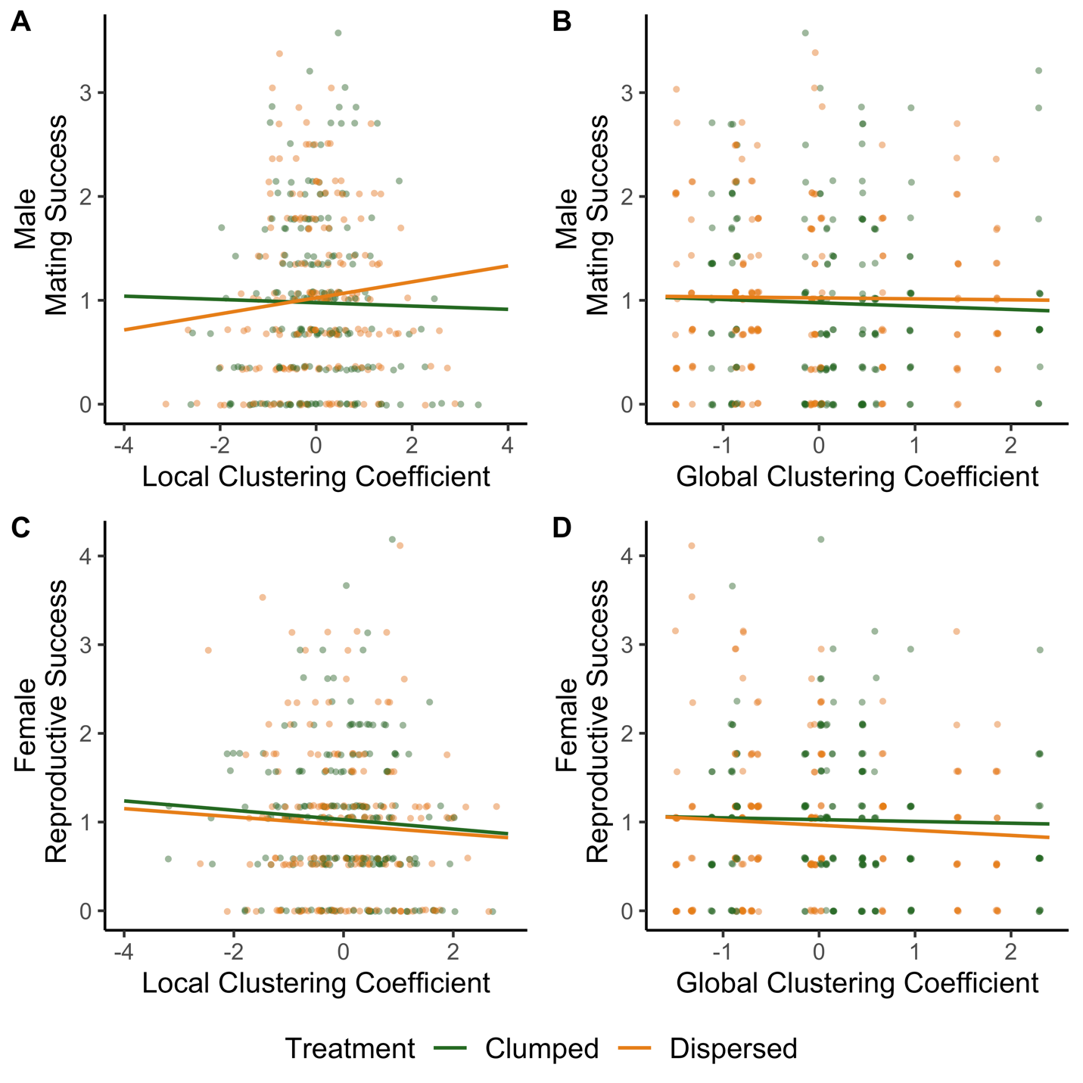
Figure 4. Marginal effects of local and global clustering coefficient from both-sex networks on male mating success and female reproductive success. (A) Male local clustering coefficient does not affect male mating success. (B) Both-sex global clustering coefficient does not affect male mating success. (C) Female local clustering coefficient does not affect the number of eggs laid. (D) Both-sex global clustering coefficient does not affect the number of eggs laid. The color of the points and gradients represent fungus resource distribution in the experimental populations. Green denotes clumped fungus resources, and orange denotes dispersed fungus resources. Confidence intervals are not included as permutation testing was used to assess significance.

